College of Applied Business & Technology
Sent-up Examination, August 2023
BIM / Third Semester / IT 215: WEB TECHNOLOGY
Candidates are required to give their answers in their own words as far as practicable. The figures in margin indicate full marks.
Section ‘A’ Time: 20 minutes
Very short answer questions. [Attempt ANY TEN] [10 × 1=10]

- Define the internet and the web.
- What do you mean by static and dynamic websites?
- Write an HTML code for the image link.
- What is CSS? Write the usage and example of it.
- Differentiate margin and padding.
- What are CSS selectors? Write an example of it.
- Write a JavaScript program to take input from the prompt and display the given input.
- What is Session and Cookies in JavaScript?
- What is react?
- What is the use of AJAX and JSON?
- What is XML?
- What is XQuery?

College of Applied Business & Technology
Sent-up Examination, August 2023
BIM / Third Semester / IT 215: WEB TECHNOLOGY I
Candidates are required to give their answers in their own words as far as practicable. The figures in margin indicate full marks.
Section ‘B’ Time: 30 minutes

Short answer questions. [Attempt ANY TWO] [2 × 5=10]

- Write the HTML program's basic structure and explain types of list tags with proper examples.[2+3]

- Write about different ways of embedding CSS in HTML page with examples.[5]
- Create a DTD having to , from, subject, message with data-type restriction, create a xml file which follow this DTD. [5]

College of Applied Business & Technology
Sent-up Examination, August 2023
BIM / Third Semester / IT 215: WEB TECHNOLOGY I
Candidates are required to give their answers in their own words as far as practicable. The figures in margin indicate full marks.
Section ‘C’ Time: 70 minutes
Long answer questions. [Attempt ANY TWO] [2×10=20]

16. Differentiate between tags and attributes? Write a HTML and CSS code design your curriculum vitae (CV) using different html elements like (table, image, formatting tags, links).[4+10]

17. Write the HTML code for following output: [10]
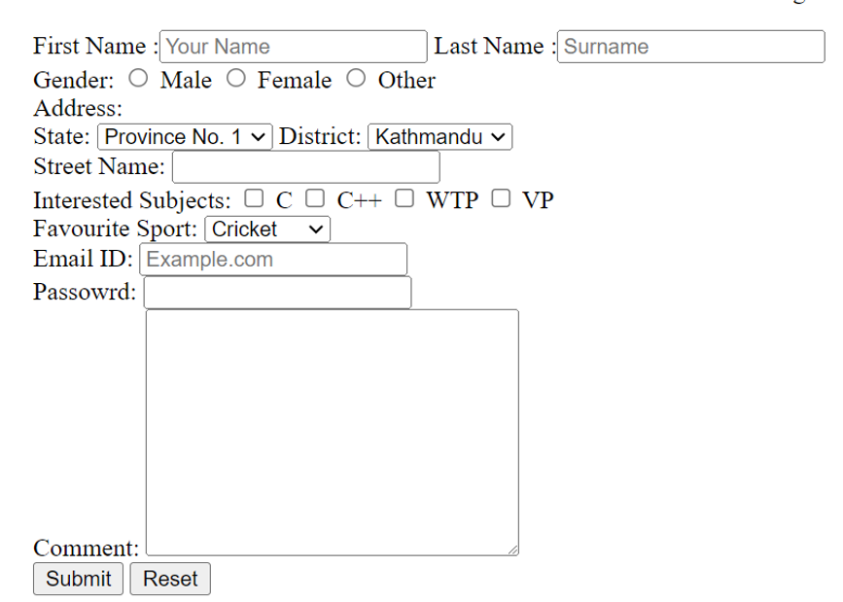

- How you can create an HTML form that allows users to input a number and then checks whether the entered number is prime or not using JavaScript.[10]

